British Commonwealth Air Train Plan (BCATP)
  - British Instructors would train pilots and other flight personnel from all over the Commonwealth in Canada
  - Between 1940 and 1945, Canada would train 137 000 aircrew, more than England and all the rest of the Commonwealth combined.

Total War
- After declaring war, the Canadian Government became much more involved in planning and controlling the economy
- April 1940, the government establishes the Department of Munitions and Supplies with C.D. Howe as Minister
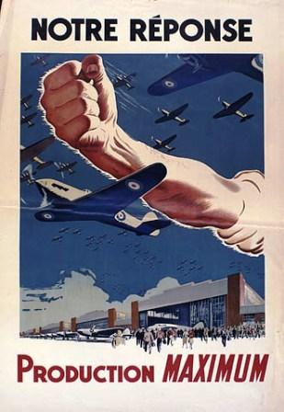
- Howe has a lot of authority, and shows it by telling industries to produce goods they had never made before.
- Vancouver built ships, and Montreal built planes and bombers (Lancasters)
- Car industries in Ontario (places like Windsor) built military vehicles and tanks
- At times, the private sector could not produce the necessary goods
- In response, Howe created Crown Corporations which were businesses and corporations owned by the government.
- Essentially, Total War meant that the government and the people were willing to do whatever it took to defeat the enemy and win the war

